Join SJTU-SEIEE: Faculty Positions in School of Electronic Information and Electrical Engineering
The School of Electronic Information and Electrical Engineering (SEIEE) invites applications for tenure-track Assistant Professor positions at Shanghai Jiao Tong University in the following thrust areas: Computer Science and Technology, Software Engineering, Electrical Engineering, Electronic Science and Technology, Information and Communication Engineering, Control Science and Engineering, Instrument Science and Technology, and Cyber Space Security.

Qualifications: All successful candidates must have a Ph.D. degree or equivalent in a relevant field by the time their appointments begin. Candidates must provide evidences of quality teaching and outstanding research.

Application Instructions: Please submit application files including a cover letter, curriculum vita, publications list and five representative publications to jobseit@sjtu.edu.cn, and indicate the research and teaching interests. Review of applications will begin immediately and continue until all positions are filled.

Salary and Funding: Salary level will be competitive and commensurate with qualifications and experience. Research funding will be provided to support the start period.

Contacts: Prof. Xinbing WANG ( xwang8@sjtu.edu.cn ) Ms. Beichen DU ( du_beichen@sjtu.edu.cn) HR Office, SEIEE, Shanghai Jiao Tong University
Tel: 86-21-3420 4522， 86-21-3420 6760
Address: 3-317 SEIEE Building,800 Dong Chuan Rd,Shanghai,200240,China More in Chinese: http://www.seiee.sjtu.edu.cn/seiee/index.htm
More in English: http://english.seiee.sjtu.edu.cn/

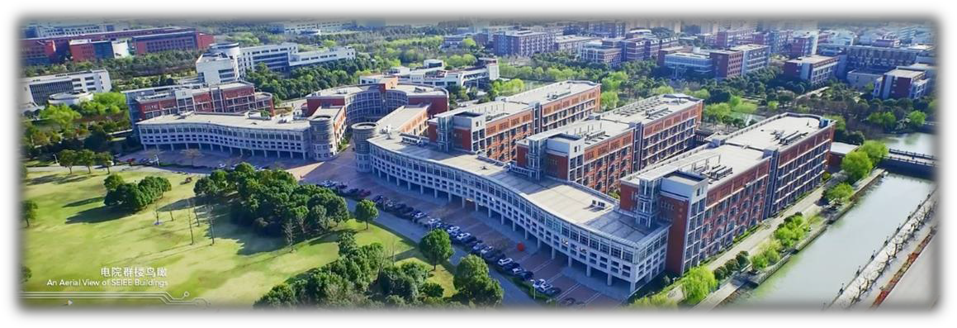

About SEIEE at SJTU

Founded in 1896, Shanghai Jiao Tong University (SJTU) is a premier university in China with a century long history of excellence in research and education. As the largest school at SJTU, SEIEE has 503 faculty members with considerable expertise and international recognition in the above eight major disciplines. With major investments from the central and municipal government, SEIEE has enjoyed significant growth over the past decade and rapidly become one of the leading engineering schools in the world. The school features 9 State Key Research Labs and
14 provincial and ministerial-level Key Research Labs, providing a dynamic environment and state-of-the-art facilities for scientific research. The school faculty has 3 academicians of the Chinese Academy of Sciences, 2 academicians of the Chinese Academy of Engineering, 13 IEEE Fellows, 14 winners of National Thousand Talents Program, and 12 Cheung Kong Scholars. The SEIEE offers top-notch educational programs for students around the world. Our highly talented students have achieved acclaimed successes at the global stage, including for example, winning the Gold Medal of prestigious ACM International Collegiate Programming Contest 6 times since its commencement.

