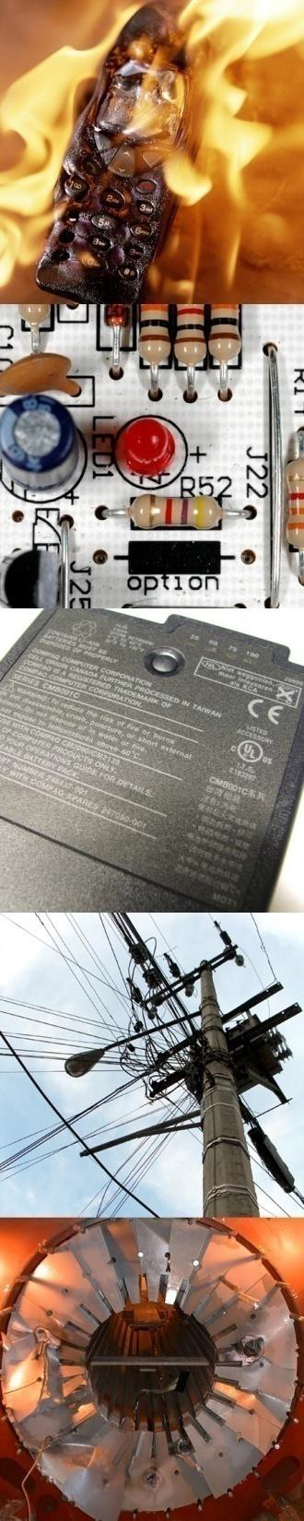

700+ Consultants • 425+ Ph.D.’s • 90+ Disciplines • 26 Offices

Exponent is currently hiring
Ph.D.’s in Electrical Engineering & Computer Science

Exponent's Electrical Engineering & Computer Science Practice includes a team of electrical engineers, computer engineers, and computer scientists performing a wide array of investigations ranging from electric power systems, to semiconductor devices, to computer networks, embedded systems, operating systems, security, and software. Exponent's electrical engineers, computer engineers, and computer scientists have experience in the areas of accident investigations, component and printed circuit board failure analysis, semiconductor device failure investigations, electrical and computer equipment failures, electric equipment fire investigations, electric motors and generators, power electronic systems for industrial and electric utility applications, power supplies and batteries, studies of electrical and electronic systems in automotive vehicles, software analysis and design, and software and firmware reliability analysis, among many others. We also perform "due diligence" investigations for investment decisions, intellectual property and technology assessments related to litigation, manufacturing plant and technology audits, engineering design process reviews, control system studies, and design reviews of electrical and electronic equipment including embedded software analysis. We operate laboratories for testing moderately heavy electrical equipment, appliances, and light electronic equipment.

- Solve detective-like problems using your electrical engineering and computer science skills
- Develop your social and business skills while working with clients ranging from
attorneys, to executives, to technical staff
- Work alongside hundreds of bright, like-minded engineers from around the world
- Help answer a wide variety of high impact engineering problems that vary day-by- day and cross over a multitude of disciplines

Current openings for Associates and Senior Associates in our Atlanta, Boston, Chicago, Los Angeles, New York, Phoenix, San Francisco, Shanghai, and Washington DC area offices!

To apply, please contact
Siobhan Costello with CV at scostello@exponent.com
and visit our website at www.exponent.com/careers

