695: HIGH-SPEED MIXED-SIGNAL IC

COMMUNICATION CIRCUITS FOR
IoT & 5G
WHY LEARN? IC FOR CONNECTED COMPUTING
Through five decades of continued transistor scaling, the size of unit computing has gone to virtually zero. In the foreseeable future, computing will be all around us, in mostly invisible forms, leading to 50+ billions of connected devices to the Internet (Internet of Things or IoT). Increasingly, connectivity (e.g. 5G) has become an indispensable part of modern computing devices. By some estimates, IoT devices will generate 3+ exabytes (one billion gigabytes) of data per day by 2018. The various communication fabrics that will handle this enormous amount data needs to be extremely energy-efficient. The advance and prosperity of CMOS technology has enabled design of these communication fabrics using mixed-signal and digital-heavy techniques, which allows for lower power, configurability and faster time-to-market. This course will build basic understanding of such mixed-signal circuits and systems and highlight their use in communication systems (wireline IO, wireless), which are becoming increasingly important in the data-driven world. The students will conduct customizable group design project on transceiver circuit design that develop design knowledge, and exposure to Process Design Kit (PDK) and EDA tools like Cadence Schematic Editor, Layout Editor, and Simulator (Hspice or SpectreRF).

FEATURING:
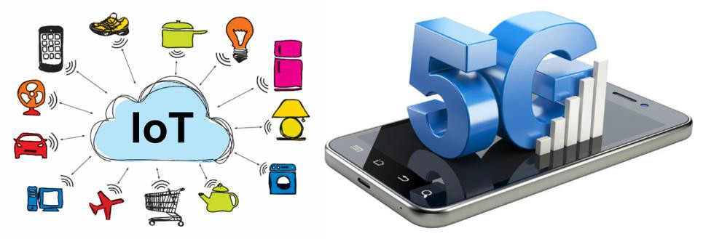
Key Building Blocks for Connectivity in IoT & 5G
MIXED-SIGNAL CIRCUITS | - WIRELINE IC
- COMMUNICATION SYSTEMS | - WIRELESS IC

PROF. SHREYAS SEN MWF 4.30-5.20 PM EE 115
PREREQUISITES: Undergraduate courses covering Linear circuits, KCL, KVL, Analog, Digital circuit design, Signal Processing, Microelectronics. Graduate Level understanding will be developed in the course itself.
SYLLABUS

Introduction

- Mixed-Signal Circuits
  - Transistors
  - Passives
  - Analog Circuits
  - Digital Circuits
  - Mixed-Signal IC

- Communication Systems
  - Analog vs. Digital
  - Broadband vs.
NarrowBand
  - Wireline Wireless
  - Bandwidth, Spectral Efficiency, Modulation
- Wireline IC
  - Applications
  - Channels
  - Transmitters
  - Receivers
  - Time-domain Samplers
  - Clock and Data Recovery
  - Equalization

- Wireless IC
  - Applications (PAN, BAN, RF, mm-wave)
  - RF System Level
  - Link Budget
  - RF Transmitters
  - RF Receivers
  - ADC

- Project
  - Transceiver Circuit Design
  - Customizable

