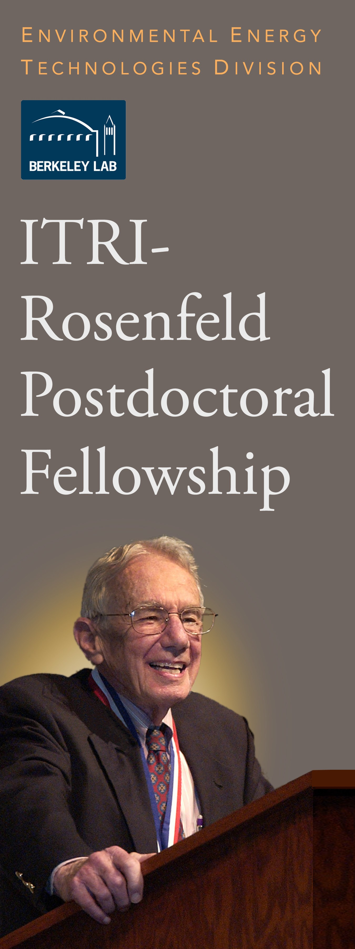for a unique postdoctoral fellowship opportunity with the Lawrence Berkeley National Laboratory.
APPLY NOW

The ITRI-Rosenfeld Postdoctoral fellowship will allow an outstanding recent or upcoming Ph.D. recipient to engage in innovative research leading to new energy efficiency technologies or policies and reduction of adverse energy- related environmental impacts.

Applications are due by November 1, 2014

The Fellowship recognizes the contribution of Arthur H. Rosenfeld, Ph.D., to the advancement of energy efficiency on a global scale, and is enabled by a gift from the Industrial Technology Research Institute of Taiwan.

Apply now or learn more at:

http://eetd.lbl.gov/about-us/itri-rosenfeld- postdoctoral-fellowship
Berkeley Lab is an Affirmative Action/Equal Opportunity Employer committed to the development of a diverse workforce.

