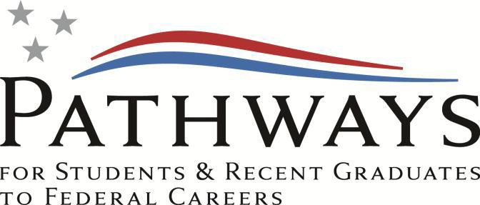

Pathways Internship Program: Fact Sheet

Overview

The Pathways Internship Program is designed to provide students enrolled in a wide variety of educational institutions, from high school to graduate level, with opportunities to work in agencies and explore Federal careers while still in school and while getting paid for the work performed. Students who successfully complete the program may be eligible for conversion to a permanent job in the civil service. Additional information about the Internship Program can be found at www.usajobs.gov/studentsandgrads/. Here are some key provisions of the Internship Program:

Eligibility

- You must be a current high school student or a current student in an accredited college (including 4-year colleges/universities, community colleges, and junior colleges); professional, technical, vocational, and trade school; advanced degree programs; or other qualifying educational institution pursuing a qualifying degree or certificate.
- Enrollment must be at least half-time as defined by the academic institution (typically six hours or equivalent for undergraduate and three hours or equivalent for graduate).
- Maintain good academic standing, generally at least 2.0 cumulative GPA for undergraduate programs and a
  - for graduate programs on a 4.0 scale).
- Must be at least 16 years of age.
- Must be U.S. citizen or a U.S. national (i.e. resident of American Samoa or Swains Island). Non-citizens may be eligible for employment if permitted by the DoD Appropriation Act or eligible to work under U.S. immigration laws. NOTE: U.S. citizenship is a requirement for a noncompetitive conversion to a permanent or term appointment with the Department of the Air Force.

Program Administration

- Agencies may hire Interns on a temporary basis for up to one year for an initial period, or for an indefinite period, to complete the educational requirement.
- Interns may work full or part-time.
- Each agency must sign a Participant Agreement with the Intern that sets forth the expectations for the internship.
- Intern’s job may be related to the Intern’s academic career goals or field of study unless the identified position has a positive education requirement (ex., engineer, biologist, geologist, nurse, recreation, etc.).

Program Completion and Conversion

- Indefinite Interns may be converted to a permanent position (or, in some limited circumstances, to a term appointment lasting 1-4 years) within 120 days of successful completion of the program.
- To be eligible for conversion, Interns must accomplish all of the following:
  - Complete at least 640 hours of work experience acquired through the Internship Program
  - Complete their degree or certificate requirements
  - Meet the qualifications standards for the position to which the Intern will be converted
  - Meet agency-specific requirements as specified in the Participant’s Agreement,
  - Perform their job successfully
- Agencies may waive up to 320 of the required 640 hours of work for Interns who demonstrate high potential as evidenced by outstanding academic achievement and exceptional job performance.
- In addition, students working in agencies through third-party intern providers may count up to 320 of the hours they work toward the 640 hour requirement.
- Time spent under previous Internship Program appointments may count towards required work experience hours.
Qualifications

- For GS-01 grade level: Current enrollment in a high school diploma program
- For GS-02 grade level: Completion of high school diploma or equivalent no later than June 2023 AND acceptance or current enrollment in an accredited college/university
- For GS-03 grade level: Completion of 30 semester hours or more of post high school study leading towards a qualifying degree (i.e. associate's, bachelor's, master's, etc.)
- For GS-04 grade level: Completion of 60 semester hours or more of post high school study leading towards a qualifying degree (i.e. associate's, bachelor's, master's, etc.)
- For GS-05 grade level: Completion of 120 semester hours or more of post high school study leading towards a qualifying degree (i.e. associate's, bachelor's, master's, etc.)
- For GS-07 grade level: Completion of 18 semester hours or more of graduate level education in a related field; OR completion of degree requirements for a bachelor’s degree with Superior Academic Achievement AND current enrollment in a graduate degree program pursuing a degree in a related field NOTE: Superior Academic Achievement is defined as based on (1) class standing, (2) grade point average, or (3) honor society membership.
- For GS-09 grade level: Completion of 36 semester hours or more of graduate level program and acceptance/ enrollment in additional master’s or doctorate degree program
NOTE: If selected, you must order and submit Official transcripts.

How to Apply

- To apply for a job, follow these steps:
- Create an account on USA Jobs at http://www.usajobs.gov.
- Upload an updated resume or create a resume using the USA Jobs Resume Builder. (Tutorials are available under the Resource Center tab on the USA Jobs website.)
- Upload up to date Transcripts and Proof of current enrollment.
- Search for jobs in the desired duty location using keywords such as “Pathways,” “Intern,” or “Student Trainee.”
- Once a position has been found, carefully follow the instructions in the “How to Apply” section of the job announcement. Be sure to submit all required documentation to verify your qualifications such as proof of enrollment, class schedules/registration, transcripts, and/or veteran’s preference documentation such as form DD-214 and/or Veteran Administration Letter of Disability Rating.
- Apply to all grades you qualify for based on the number of anticipated completed credit hours for the current semester by the closing date of the announcement. Qualifying grade will be determined at time of referral based on available positions and number of credit hours the student expects to complete at the end of the semester.
- Applicant may update application package and supporting documents until the closing date of
the announcement, for example: Updated transcripts with credit hours earned to meet education requirement, etc.

Application Tips

  - To avoid any delay in the application process, students should prepare resumes and have the following documentation ready:
      - Official or unofficial transcripts (must reflect current cumulative GPA & total semester/quarter hours). **If transcripts do not reflect in-progress courses, a class schedule/registration is required.**
NOTE: Official transcripts must be mailed, digitally transferred, etc. to the agency on school letterhead
      - Students who are matriculating from one degree program to another must provide an acceptance letter to verify continuing education.
      - A letter of enrollment on official university letterhead may be provided in place of the required documentation (must reflect current cumulative GPA, total semester/quarter hours, in-progress courses and/or program acceptance).

