

# Big Ten+ Grad Expo | College of Engineering Schedule

Considering Engineering for graduate school? You are in the right place! The 2020 Big Ten+ Grad School Expo is a Virtual Experience for students interested in STEM related disciplines.

Do you want Zoom links for the Purdue Engineering Big Ten+ Graduate School Expo Schedule below? [Register to attend the Big Ten+ Grad Expo for free!](https://gradapply.purdue.edu/register/GradExpo)

# Sunday October 4th, 2020

This portion of the 2020 Big Ten+ Grad School Expo is a Virtual Experience for students interested in learning more about Engineering. At this Sunday Session you will be welcomed by the Purdue Engineering Office of Graduate Education and hear insights from our current Graduate Students.

*All times are in Eastern*

|  |  |
| --- | --- |
| **Time** | **Event** |
| 4:30pm | **Engineering Welcome** |
| 5:00 - 6:00pm | **Graduate Student Panel:**  *Ángel Enriquez (Biomedical Engineering)*  *Somosmita Mitra (Electrical and Computer Engineering) Dayna Obenauf (Mechanical Engineering)* |
|  |  |
| 6:00 - 6:45pm | **Virtual Tours of Research Centers** |
|  | *Birck Nanotechnology Center* |
|  | *Bowen Laboratory for Large-Scale Civil Engineering Research* |
|  | *Herrick Laboratories* |
|  | *Zucrow Propulsion Laboratories* |
|  | *(Tentative) Chemical Engineering research facilities* |
|  |  |
| 6:45pm | **Breakout Sessions by Engineering Disciplines** |
|  | *Aeronautics and Astronautics* |
|  | *Agricultural and Biological Engineering* |
|  | *Biomedical Engineering* |
|  | *Chemical Engineering* |
|  | *Civil Engineering* |
|  | *Electrical and Computer Engineering* |
|  | *Engineering Education* |
|  | *Environmental and Ecological Engineering* |
|  | *Industrial Engineering* |
|  | *Materials Engineering* |
|  | *Mechanical Engineering* |
|  | *Nuclear Engineering* |
|  | *Engineering Management* |
|  | *Online Engineering* |



# Monday October 5th, 2020

**Engineering Presentations or Research Info Sessions** – Engage with a variety of presenters and topics related to graduate study in Purdue Engineering! Purdue Engineering Presentations change each hour. You are welcome to come and go to any sessions that interest you.

*All times are in Eastern*

|  |  |  |  |
| --- | --- | --- | --- |
| **Time** | **Session 1** | **Session 2** | **Session 3** |
| 10:00 - 10:45am | **Chemical Engineering Presentation**  (Prof. John Morgan and Prof. Raj Gounder, Davidson School of Chemical Engineering) | **Sustainable Transportation Systems Research** (Lisa Losada and Sarah Adsit,  Graduate Students, Lyles School of Civil Engineering) | **Introduction to School of Materials Engineering** (Prof. Dave Bahr and Prof.  Xinghang Zhang, School of Materials Engineering) |
| 11:00 - 11:45am | **Chemical Engineering Professional Master's Program Presentation** (Corwin Green and Prof. Bill Clark, Program Directors, Davidson School of Chemical Engineering) | **Research on Nuclear Engineering Thermal- hydraulics and Reactor Safety**  (Dr. Ran Kong, Postdoctoral Researcher, Drew Ryan and  Adam Dix, Graduate Students, School of Nuclear Engineering) | **Leveraging Undergrad Research Experiences to Improve Your Graduate Application**  (Darshini Render, Assistant Director and Prof. John Howarter Director,  Engineering Undergraduate Research) |
| 12:00 - 12:45pm | **Engineering Meets the Social Sciences: Distinguish Yourself!**  (Prof. Brent Jesiek, School of Engineering Education) | **Purdue Complex Flow Lab**  (Prof. Arezoo Ardekani, School of Mechanical Engineering) | **Purdue Mechanical Engineering Solid Mechanics**  (Prof. Thomas Siegmund, School of Mechanical Engineering) |
| 1:00 - 1:45pm | **Overview of Research Areas in**  **Aeronautics & Astronautics**  (Prof. Greg Blaisdell, School of Aeronautics & Astronautics) | **Technical Leader Career Launchpad: Professional Master’s Programs**  (Eric VandeVoorde, Director of Professional Master's Programs) | **Energy Systems, Renewable Energy, Thermal Transport & Sustainable Energy Research at Purdue** (Prof. Xiulin Ruan (Moderator, ME); Prof. Shweta Singh (ABE); Prof. Rakesh  Agrawal (ChE); Prof. Rebecca Ciez (EEE/ME) |
| 2:00 - 2:45pm | **Insider Application Tips & Career After your Industrial Engineering Degree**  (Anita Park, Senior Graduate Program Administrator; Dave Kotterman, Director of Industry Relations, School of  Industrial Engineering) | **Water Quality Research at Purdue** (Presenters are being finalized. Check final schedule for details!) | **Robotics Research at Purdue**  (Presenters are being finalized. Check final schedule for details!) |

|  |  |  |  |
| --- | --- | --- | --- |
| 3:00 - 3:45pm | **zEDGE Tiny House (zero Energy Design Guidance for Engineers** (Prof. Nusrat Jung, Lyles School of Civil Engineering) | **Biomechanics, Biomaterials, & Tissue Engineering Research at Purdue**  (Presenters are being finalized. Check final schedule for details!) | **Opportunity for Graduate Research in New Energy Technologies with the Engineering Research Center “CISTAR”**  (Dr. Denise Driscoll, Diversity and Inclusion Director; Prof. Fabio Riberio, School of Chemical  Engineering and CISTAR Director) |
| 4:00 - 4:45pm | **Herrick Labs**  (Prof. Jeff Rhoads, School of Mechanical Engineering) | **Purdue Additive Manufacturing**  (Prof. Yung Shin, School of Mechanical Engineering) | **Propulsion Research at Purdue**  (Prof. Steve Son (Moderator, ME); Prof. Robert Lucht (ME); Prof.  Timothée Pourpoint (AAE); Prof. Stephen Heister (AAE)) |
| 5:00 - 5:45pm | **Explosives, Propellants, and Pyrotechnics: the Purdue Energetics Research Center**  (Prof. Steve Beaudoin, Davidson School of Chemical Engineering) | **Structural Engineering Research at Purdue**  (Prof. Mohammad Jahanshahi, Prof. Julio Ramirez, Prof.  Shirley Dyke, and Prof. Christopher Williams, Lyles School of Civil Engineering) | **Benefits of an Online Degree**  (Amanda Silva, Purdue Online, College of Engineering) |

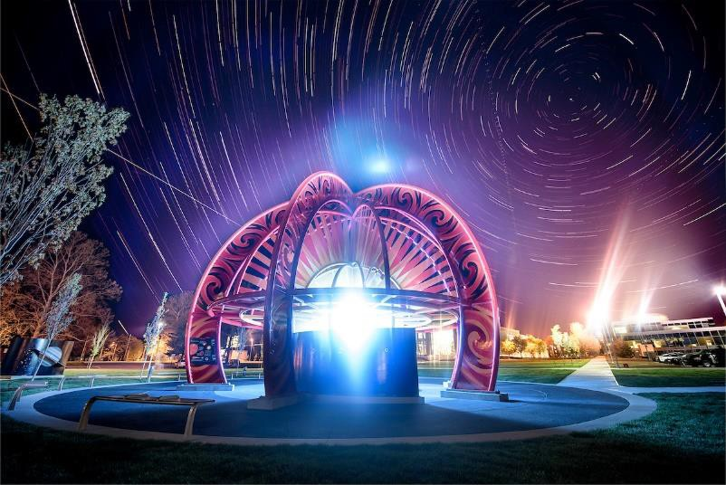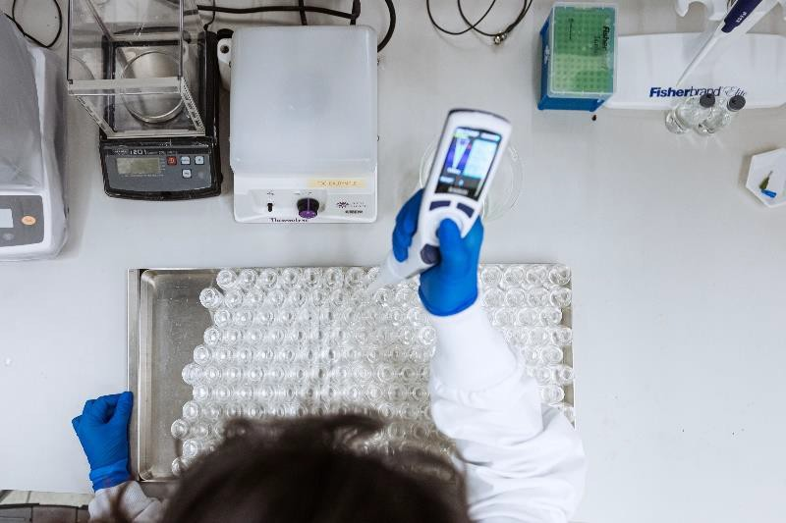

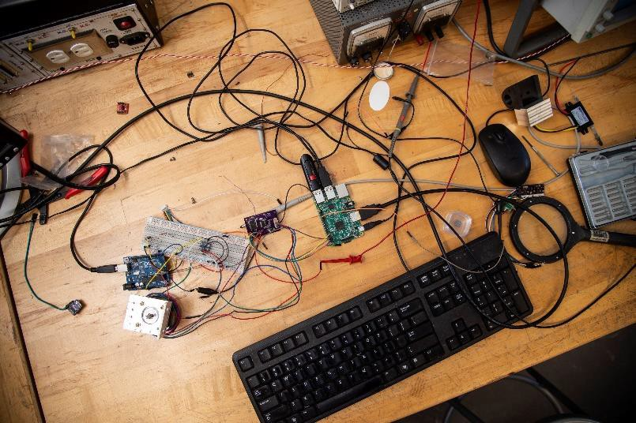 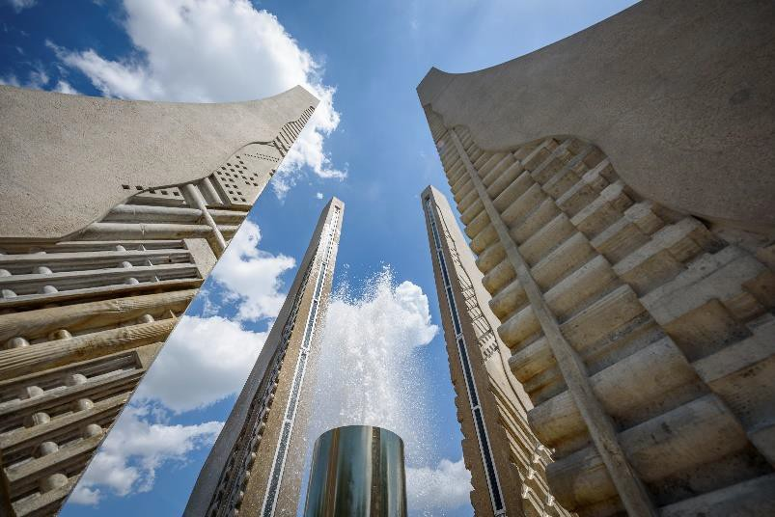



# Monday October 5th, 2020

**Virtual Graduate Fair Booth Information** – Visit with your Engineering Program of interest to learn more through our Virtual Fair Booth!

*All times are in Eastern*

|  |  |
| --- | --- |
| **Time** | **Virtual Graduate Fair Booth** |
| **10:00am - 6:00pm** | **College of Engineering** |
| 10am - 12pm; 3pm - 5pm | Aeronautics and Astronautics |
| 12pm - 2pm | Agricultural and Biological Engineering |
| 10am - 12pm; 1pm - 3pm | Biomedical Engineering |
| 10am - 6pm | Chemical Engineering |
| 10am - 6pm | Civil Engineering (general) |
| 11am - 12pm | *Hydraulics Q&A Session – Dept Head Dr. Govindaraju* |
| 11am - 1pm | *Structures Q&A Session – Dr. Ramirez and Dr. Prakash* |
| 1pm – 2pm | *Geomatics Q&A – Dr. Jung* |
| 5pm – 6pm | *Construction Q&A – Dr. Abraham* |
| 10am - 12pm | Electrical and Computer Engineering |
| 10am - 6pm | Engineering Education |
| 10am - 12pm | Environmental and Ecological Engineering |
| 2pm - 4pm | Industrial Engineering |
| 10am - 6pm | Materials Engineering |
| 10am - 6pm | Mechanical Engineering - (HT/Thermo) |
| 10am - 12pm; 1pm - 5:30pm | Mechanical Engineering - (SYS/Measure/Control) |
| 10am - 12pm; 1pm - 6pm | Mechanical Engineering – (Dynamics/Vibration) |
| 12pm - 2pm | Nuclear Engineering |
| 12pm - 5:30pm | Master's of Engineering Management |
| 2pm - 4pm | Online Engineering |

# Monday October 5th, 2020; 6pm Eastern

**Closing Session | Purdue Engineering** - Set goals, determine your next steps, and close out the Big Ten+ Graduate School Expo with Purdue Engineering!

Do you want Zoom links for the Purdue Engineering Big Ten+ Graduate School Expo Schedule? Register to attend the Big Ten+ Grad Expo for free!