Software Formalization

Year: 2025 Semester: Spring Team: 16 Project: SHALL

Creation Date: 02/21/2025 Last Modified: February 21, 2025

Author: Gino Ako Email: gakoii@purdue.edu

Assignment Evaluation: See Rubric on Brightspace Assignment

1.0 Utilization of Third-Party Software
The Smart Home Adapter for LED Lights (SHALL) project incorporates several third-party software libraries and frameworks to enhance system performance, streamline development, and enable us to make use of smart home integration, LED control, and audio processing. The table below details the third-party software used, its licensing, purpose in the project, and any necessary compliance steps.
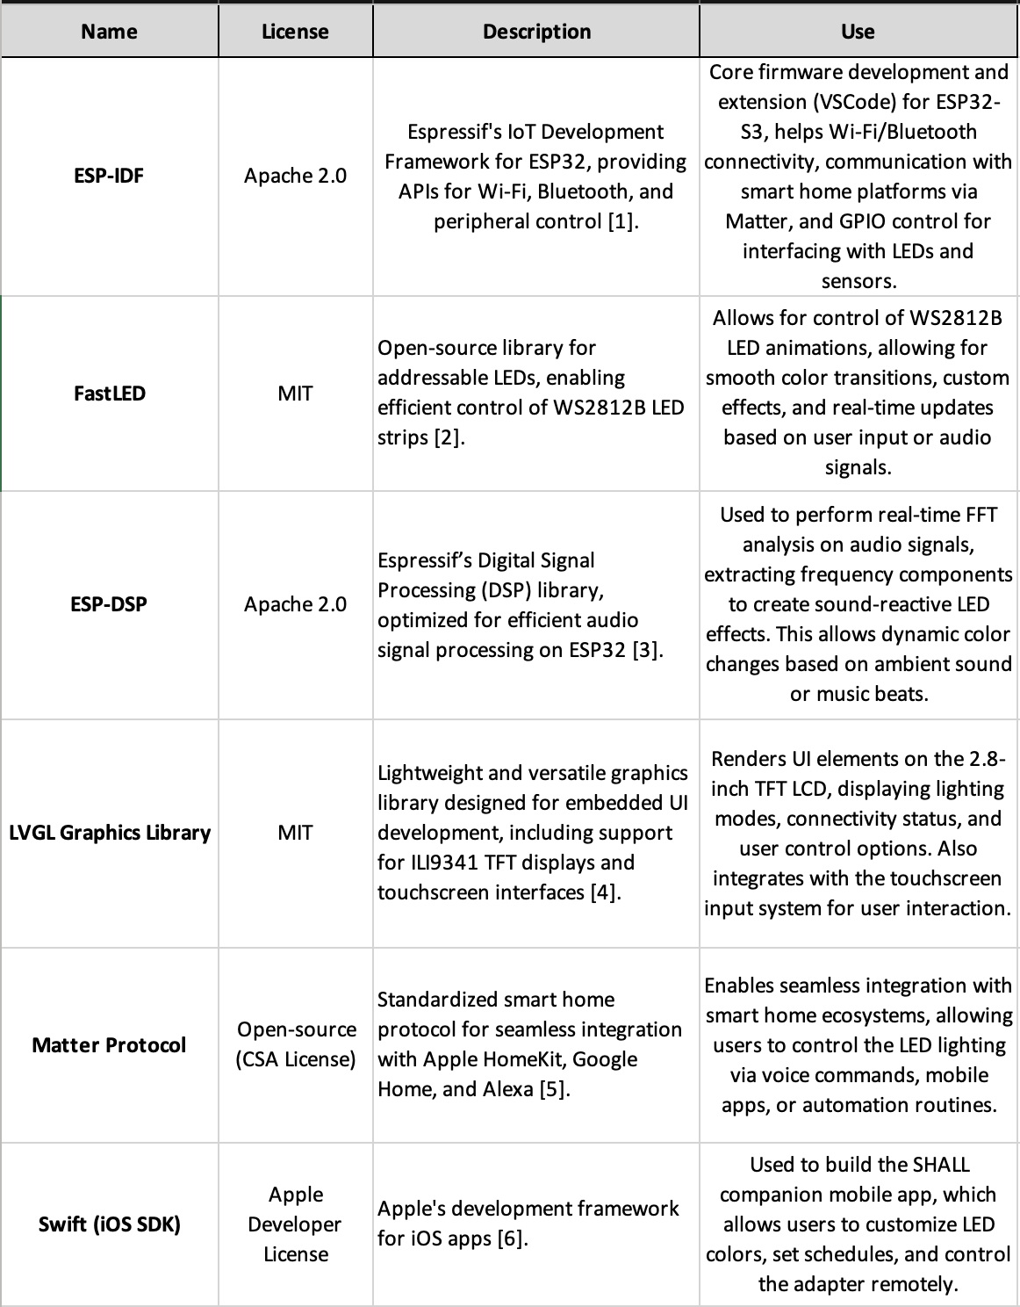
Table 1: Table of Utilization of Third-Party Software
All open-source software listed above follows the proper licensing requirements. Some components, such as the Swift SDK, require an Apple Developer Account for full usage. The compliance with Matter Protocol specifications is maintained under CSA licensing regulations.

2.0 Description of Software Components

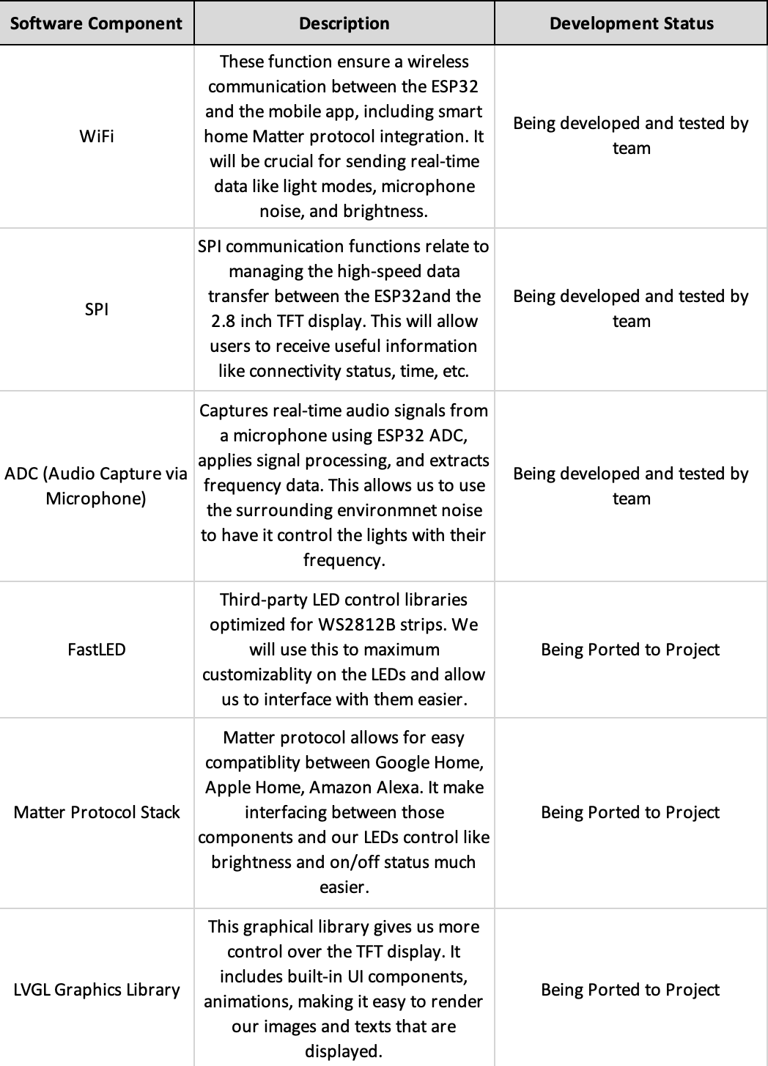

3.0 Testing Plan

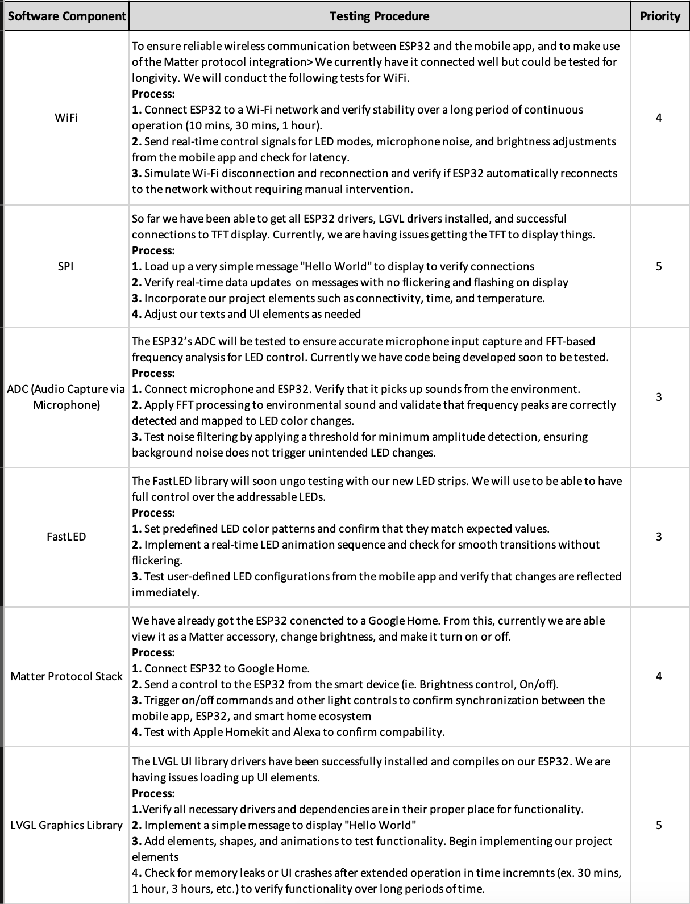

4.0 Sources Cited:
[1] Espressif Systems, “ESP-IDF Programming Guide,” Available: https://docs.espressif.com/projects/esp-idf/en/stable/.
[2] Adafruit Industries, “Adafruit NeoPixel Überguide,” Available: https://learn.adafruit.com/adafruit-neopixel-uberguide.
[3] Espressif Systems, “ESP-DSP Library for Digital Signal Processing on ESP32,” Available: https://github.com/espressif/esp-dsp.
[4] LVGL Graphics Library, “Light and Versatile Graphics Library,” Available: https://lvgl.io/.
[5] Connectivity Standards Alliance, “Matter Specification,” ver. 1.0, Oct. 2022. Available: https://csa-iot.org/all-solutions/matter/.
[6] Apple Inc., “Swift Programming Language Guide,” Available: https://developer.apple.com/swift/resources/.

Appendix 1: Software Component Diagram

LED Control Diagram:

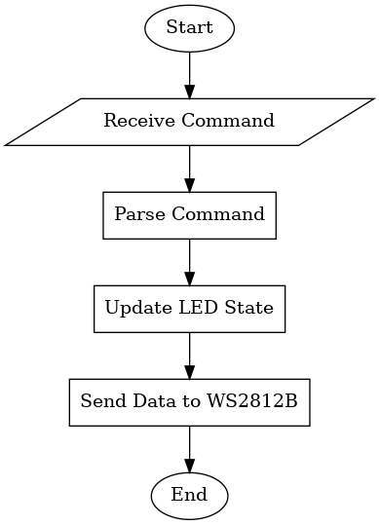

Microphone Control Diagram:

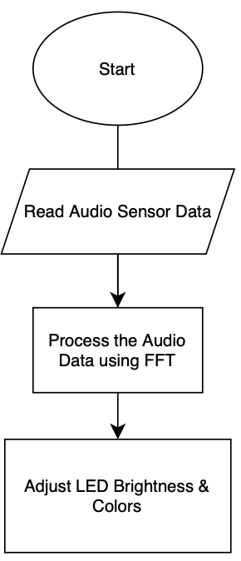

TFT Display Control Diagram:

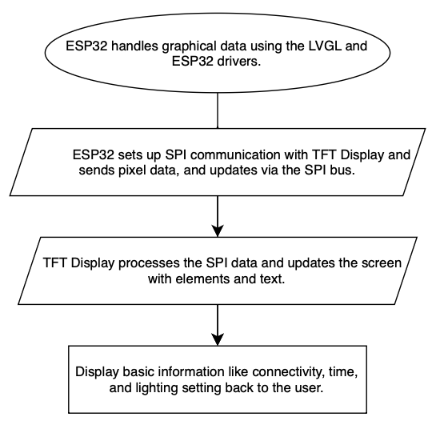

ESP32 Software State Machine Diagram:

