Year: _2025_____ Semester: __Spring______ Project Name:______AquaCare___
Date of First Submission: ­______________________ Last Modified: February 9, 2024

Team Members (#1 is Team Leader):
Member 1: ____Saimak Maitra______ Email: ______maitra@purdue.edu________
Member 2: _____Lechuan Wang_____ Email: ____wang5235@purdue.edu___
Member 3: _____Austin Rejman____ Email: ___arejman@purdue.edu___
Member 4: ____Caroline Thomas___ Email: ___cgthomas@purdue.edu______

Project Abstract:
Our team wants to create a smart fish tank for the project, which could take the hassle out of fish care by automating feeding, monitoring water quality, and maintaining ideal conditions for healthy fish. Our setup will use an STM32F091 microcontroller along with several sensors, including pH, temperature, and oxygen level sensors, to keep track of water quality. The system will automate feeding times, notify users when to change the water filter, and alert them if any readings go out of the safe range for the fish. By simplifying these routine tasks, this smart tank aims to reduce the hassle of fishkeeping for hobbyists and pet stores, helping fish stay healthier with less hands-on work from the owner.

1.0 Description of Problem:
Fishkeeping is popular, with 12 million people in the U.S. alone owning pet fish according to the American Pet Products Association (APPA) [1]. However, keeping a tank healthy can be time-consuming. Water quality needs to be carefully maintained, with the right pH, oxygen levels, and regular cleanings. Small changes in water quality or missed feedings can quickly harm the fish, which is a common issue for busy owners who may forget to do these tasks. Pet stores also face these challenges, needing to keep tanks healthy across different locations, which can add up in time and costs.
An automated fish tank system could help by taking over routine tasks like checking water quality, feeding, and alerting the owner about maintenance needs. This would make fishkeeping easier and more manageable for hobbyists and pet stores, allowing them to spend less time worrying about tank upkeep and more time simply enjoying their fish.

2.0 Proposed Solution:
Our solution is a smart fish tank system that automates the key tasks of fishkeeping to make it easier for owners to maintain a healthy environment. The system will continuously monitor the tank's pH levels, temperature, and oxygen levels using dedicated sensors. When any of these values move outside the safe range, the system will send an alert to notify the user, helping them act before conditions become harmful to the fish.
To simplify feeding schedules, the tank will have an automatic feeder that can be programmed to release food at set times each day. This will ensure fish are fed regularly, even if the owner is not present. The system will also track the filter’s condition and alert the user when it’s time to replace it, preventing the build-up of waste that could harm the fish.
The smart tank will include a display or app integration for easy monitoring, allowing users to view all tank conditions and receive alerts in real time. By automating these essential functions, the system will reduce the hands-on work required to maintain a healthy fish tank, making it ideal for both home hobbyists and pet stores looking for a more efficient way to care for their fish.
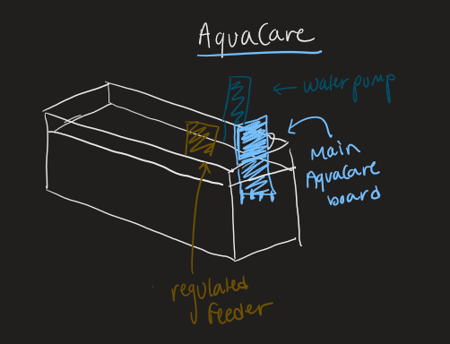
Setup Concept Sketch
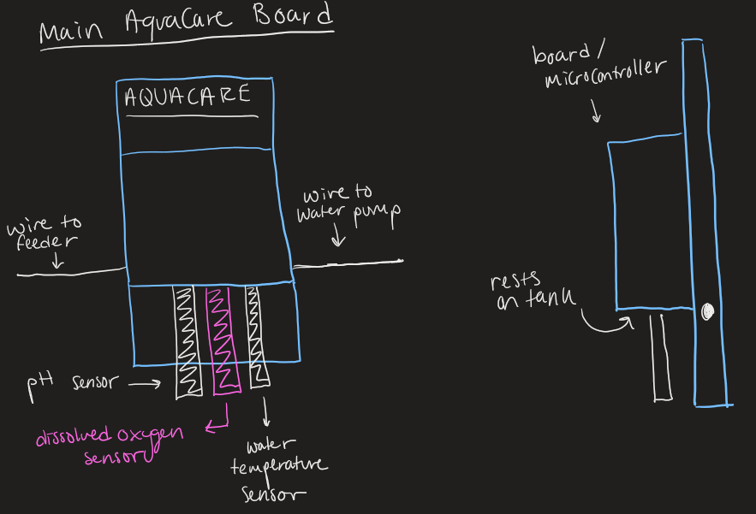
AquaCare Board Concept Sketch
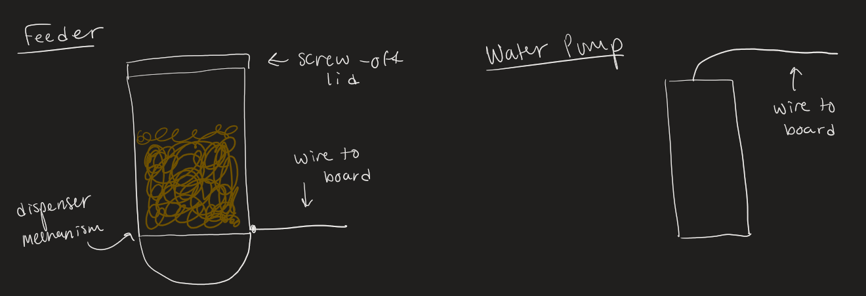
AquaCare Feeder/Water Pump Concept Sketch
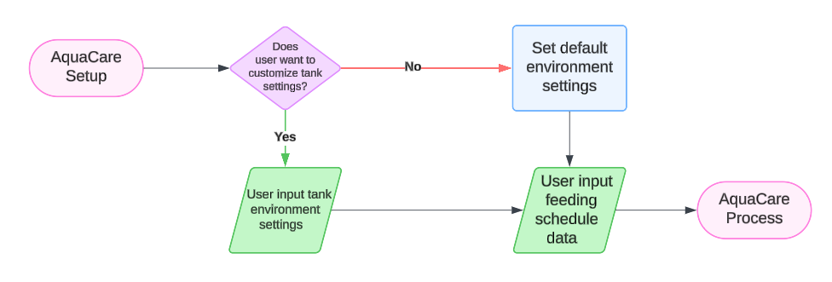
AquaCare Setup
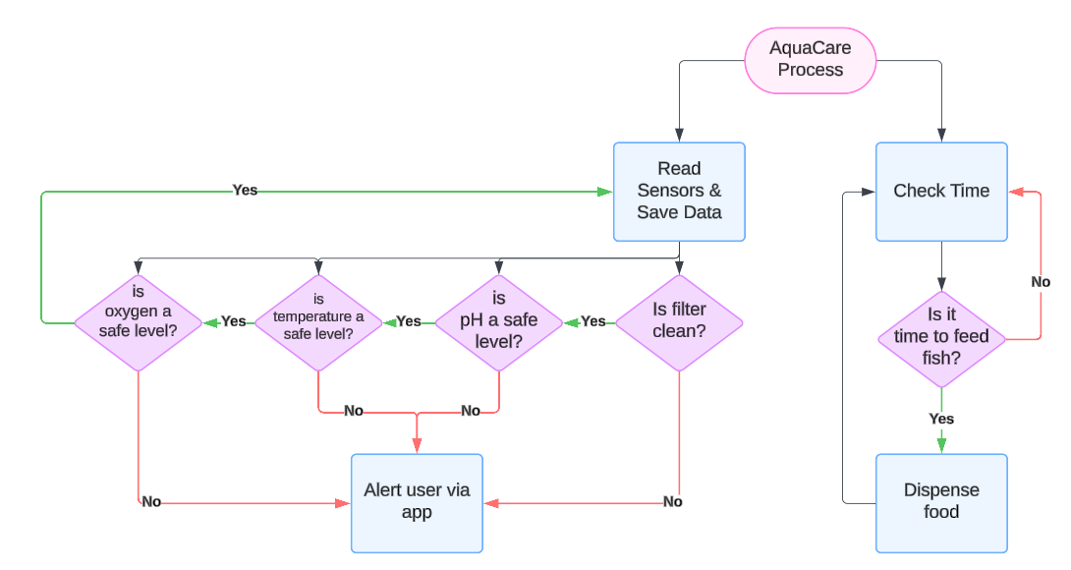
General AquaCare Process

3.0 ECE 47700 Course Requirements Satisfaction
3.1 Expected Microcontroller Responsibilities
The STM32F091 microcontroller will be responsible for periodically sampling the pH sensor’s analog output to measure water acidity/alkalinity. It will also sample the analog output to assess oxygen levels in the water, monitor water temperature through regular sampling, ensure stable power supply levels for each sensor (and other components) by monitoring voltage and current values. Utilize ADC channels to sample sensor outputs. Periodically calibrate sensor readings against known reference values for accuracy. Implement low-pass filtering in software (or hardware) to reduce noise in analog readings. Automatically activate the pump motor based on oxygen and pH levels or a timer. Operate automatic food dispenser motor based on a set feeding schedule or manual override. Use PWM or GPIO control to drive motors, with relays or motor driver circuits if needed. Add safety conditions to prevent motors from running continuously or at inappropriate times. Display real-time sensor readings utilizing the LCD display and use an I2C or SPI interface (depending on LCD type) for communication with the display. Implement a menu system for accessing different screens or settings on the LCD. Regularly check power readings and set flags or error codes if abnormalities are detected. Display alert messages on the LCD if any readings exceed predefined safe limits. If remote monitoring is required, consider adding serial (UART) or I2C/SPI communication to transmit data to an external monitoring device or logging system. Implement timers for regular sampling of sensors and control of the food dispenser based on the time of day or at specific intervals. Use hardware timers to schedule tasks without blocking other functions. Ensure efficient use of the processor with interrupt-driven or DMA-based ADC sampling to keep the system responsive.

3.2 Expected Printed Circuit Responsibilities
Our project will include a pH analog sensor, dissolved oxygen analog sensor, analog water temperature sensor, water pump motor, automatic food dispenser motor, voltage/ampere regulator for all sensors and motors, possible LCD display for monitoring of the tank, working with STM32F091 microcontroller. This PCB will be designed to manage data acquisition, control signals, and power regulation efficiently, forming a central hub for monitoring and maintaining the fish tank’s conditions.

4.0 Market Analysis:
The primary market for our automated fish tank system includes aquarium hobbyists, pet stores, and people interested in smart home tech with a focus on pet care.
For Aquarium Hobbyists, roughly 12 million U.S. households keep fish, according to the American Pet Products Association (APPA) [1]. Many hobbyists struggle to maintain consistent water quality and feeding schedules. About 60% find it difficult to keep up with tank conditions due to the regular attention required for pH, ammonia, and nitrate levels, plus daily feeding. Our system aims to help by automating monitoring, sending alerts, and reducing the manual upkeep fish care requires.
Pet Stores like PetSmart and Petco also need to maintain stable water conditions to keep fish healthy before sale. Automating these tasks would allow stores to standardize tank care across multiple locations, helping to prevent disease and lower maintenance costs. A system like this could be valuable to stores aiming for consistent and high-quality fish care.
Smart Home and Pet Care Enthusiasts represent another market, as interest in smart, automated pet-care systems grows. This group often values the convenience of app-integrated devices and the ability to get real-time notifications. With options to integrate our system into smart home platforms like Alexa or Google Home, it could be a strong option for those already invested in home automation.
We’re aiming for a price range of $200-$400, which positions it well for both individual hobbyists and pet stores. With even a modest 10% share of the hobbyist market, there’s significant revenue potential, with further B2B opportunities for pet retailers.

5.0 Competitive Analysis:
5.1 Preliminary Patent Analysis:
5.1.1 Patent KR101888602B1: Aquarium Remote Management System
This patent covers a system for remote aquarium monitoring that focuses mainly on keeping the water temperature stable and tracking the status of the heater, cooler, and pumps. It uses sensors to measure water temperature and the power used by these devices, allowing it to alert users if something needs fixing. Users can get real-time notifications on their phones and adjust the temperature settings remotely.
While this system is helpful, it’s limited to temperature control and basic equipment monitoring. Our project goes further by also tracking water quality and oxygen levels, which are key to keeping fish healthy. Plus, we’re adding an automated feeder, so users don’t have to remember feeding schedules. Overall, our design aims to give aquarium owners more control over their tank’s health with less hassle than what this patent offers.

5.1.2 Patent KR20220071424A: Smart Automatic Fish Tank
This patent describes a smart fish tank system pretty similar to ours, with features like an automatic feeder, a water level sensor, and a temperature monitor to make fish care easier. The system is designed to handle feeding, control the water level, and keep the temperature stable.
One thing this system has that ours doesn’t is the water level sensor, which could be a good addition to prevent overflows and keep things consistent. Still, our design plans to go further by adding water quality and oxygen level monitoring, giving it a more complete approach to maintaining a healthy tank for the fish.

5.1.3 Patent CN105454136B: Self-Circulating Purification Smart Fish Tank
This patent covers a smart fish tank that takes a lot of the work out of fish care by automating things like feeding, water changes, and oxygenation. It uses a central processor to control pumps, a filter, an automatic feeder, and even cameras around the tank. The system also lets users monitor and control the tank remotely through a mobile app, which can adjust water levels, check oxygen and mineral levels, and control feeding schedules.
While this design is packed with features similar to ours, it has a few extras, like a fully automated water change system and the ability to add medication to the tank through an integrated dispenser. It also includes multiple cameras for real-time viewing from different angles. In our design, we’re focusing more on water quality and oxygen monitoring rather than water changing or medication, which keeps our setup simpler but still covers essential fish care. This patent gives us ideas for potential upgrades if we want to expand our system’s features later on.

5.2 Commercial Product Analysis:
5.2.1 Seneye Home Aquarium Monitor:
The Seneye Home Aquarium Monitor is a device that contains numerous sensors that can detect and keep track of pH levels, the temperature, ammonia, and light levels in the fish tank [2]. These parameters can then be displayed and viewed via the company's own app through either mobile or PC enabling the tank owners to moderate these qualities. This works using the Seneye device, which is a singular rectangular device connected to a wire that can be connected to any outlet. THe device can be connected to a PC via USB or a separate network box for WiFi. The benefits to this product is its capability of alerting the user in real-time, providing numerous and important water quality metrics, and containing USB connectivity. However, this can also require the user to buy extra accessories to connect via WiFi or display extra qualities of the tank. Our product provides more metrics than Seneye, an example being the oxygen levels, and will perform some automated features like automated water pumps, filtration, and feeding.
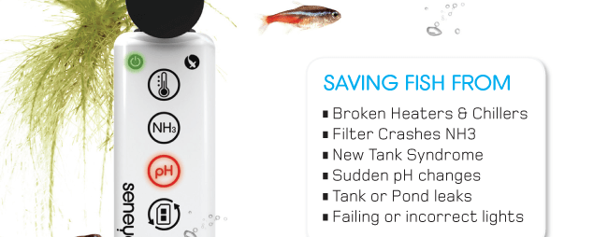
5.2.2 Fishbit Smart Monitor:
The Fishbit Smart Monitor is a controller device monitor that tracks pH, temperature, and salinity of an aquarium [3]. These qualities can be monitored with its own mobile app that allows the tank owners to receive real-time data and alerts. This device is designed to work in saltwater environments which mainly include reef tanks. The device is designed with many sensors detecting these qualities in the aquarium and uses WiFi to send data to the mobile app. This device is great for tracking important qualities, it has a user-friendly interface with a strong app integration, and provides good WiFi connectivity to simplify access to data on mobile devices. However, the cons that come with this product include the device’s limit to saltwater parameters, making it less versatile for freshwater tanks, and does not include any automated actions. Meanwhile, our product provides more data that can be monitored and compatible with both freshwater and saltwater, while providing automated functions to aid the aquarium. Fishbit is limited to mainly larger aquariums, since larger aquarium fish require salt water.
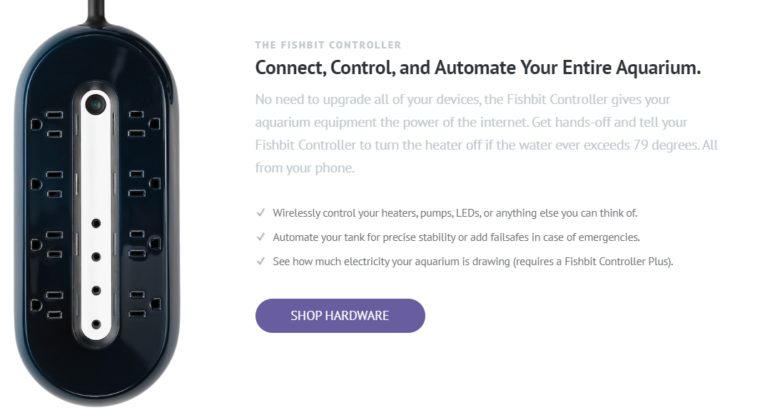

5.2.3 Apex Controller:
The Apex Controller by Neptune Systems is a controller for aquariums that can measure numerous quality parameters like pH, temperature, salinity, ORP, dissolved oxygen, and even can extend to other parameters depending on specific models [4]. This controller has many ports that can connect to many devices like its temperature, pH, OPR probes, multiply different sensors, ethernet port,and can extend to many other ports depending on upgraded models. This controller also provides a cloud-based app to access and control all these parameters, providing automation for lighting, pumps, and dosing. The Apex controller also provides the option of custom settings to the fishtank user. This product contains many pros as it can monitor and control multiple water parameters and devices, can be used or connected to many other external devices via WiFi or wire, can be customized to a high degree, and can be remote controlled via cloud integration, which can provide real-time monitoring and alerts. Although this product contains numerous pros, the product is high-end and expensive. A normal controller can cost $600 while upgraded models like the ApexPro controller can be nearly $1000, making this out of reach for casual aquarium owners. In addition, with all these features and parameters, this product does not provide a user-friendly interface as it is complex to set up and program. This would require the user to spend time learning how to adjust and use the Apex controller. While our product does have as many parameters to monitor or many different types of automation, our product is cheaper and is the perfect balance of capturing relevant data, and relevant automation. Some products do not contain any automation and only display some parameters. While others like Apex Controller display too much, our product meets in the middle to make it as effective as possible and user-friendly.
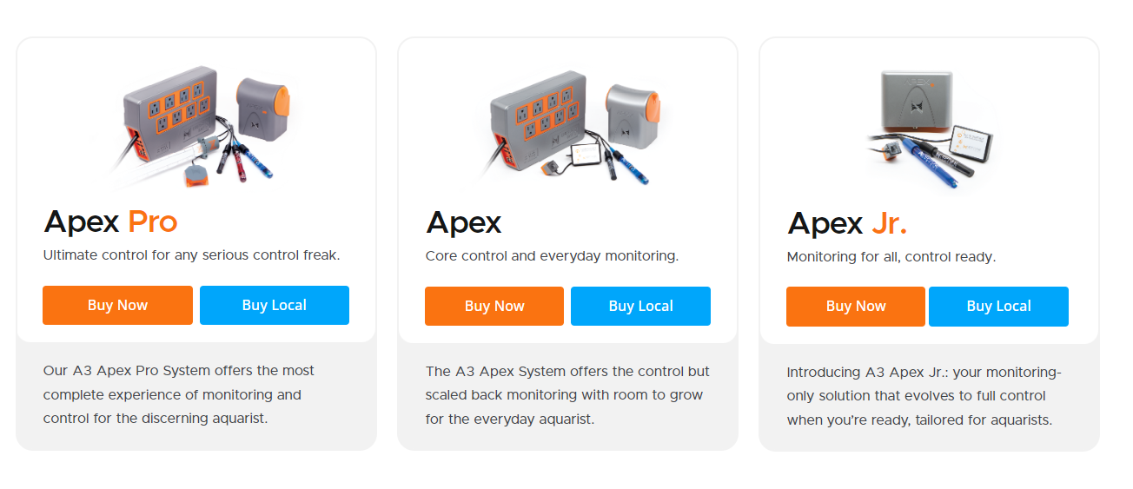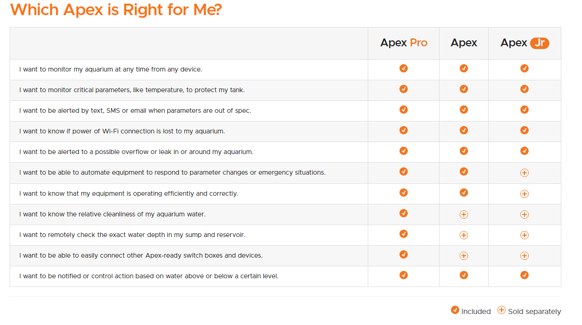
5.3 Open Source Project Analysis:
5.3.1 Smart-Aquarium-Project:
The Smart-Aquarium-Project was created by a University of Illinois at Chicago student named Yash Kurkure according to his GitHub repository [5]. This project is designed to monitor certain water parameters such as pH, temperature, and light levels with its own automatic feeding system. The project is Arduino-based, and uses a mobile app to remote-control and monitor the parameters with WiFi communication. This can provide pros as it is affordable and accessible being arduino-based. In addition, the automations and code provided in this one-project is fairly basic and not too complex. However, because of how basic it can be, this limits the monitoring scope which cannot cover some parameters, like oxygen levels. Using the Arduino controller, a circuit board, and many other hardware components used on the circuit board, some aspects can be adapted to aid our own product, like the mobile app and the type of sensors used. A license for this open source project is provided by the GitHub user stating the permission, free of charge, of any person to use a copy of the project’s code and modify it in any way.
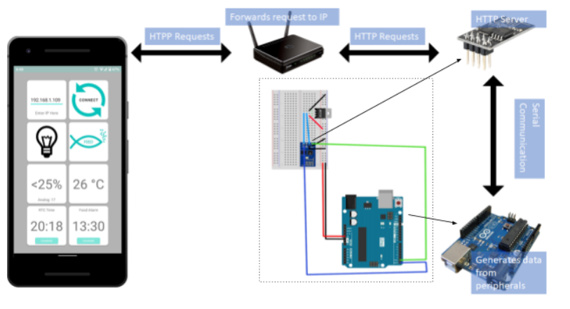

5.3.2 Reef-Pi:
Reef-Pi is an open-source aquarium controller project created by a group called Adafruit [6]. The project's aim is to provide a controller for aquariums to be able to control certain parameters of the fish tank. The controller consists of multiple different hardware parts and two different circuit boards to contain this massive device. This project not only monitors salinity, temperature, light, and pH, but all these parameters are automatically controlled through the controller. An example is that if the controller detects the water level is below a certain value, the controller will automatically pour in more fresh water until the threshold is met. This is automated through all the parameters as well as other features are included like automatic feeding, automatic light cycles to make aquarium plants thrive in photosynthesis, and an automatic multi-step reef keeping process like water change. The benefits of this design is that it is Raspberry Pi-based, making it flexible in connectivity and automation and the MIT license allows us for commercial adaptations. However, some of the automation and parameters are mainly focused on reef tanks, so it would be costly to have some functions that are unnecessary for freshwater tanks. This project provides sufficient aspects to adapt from to help our own solution. Some examples could potentially be the adaptation of their automated feeding system as well as how they control their parameters so that filtering would be automatic. The licenses of this project is under MIT license, making it possible for commercial use and modification without share-alike requirements.
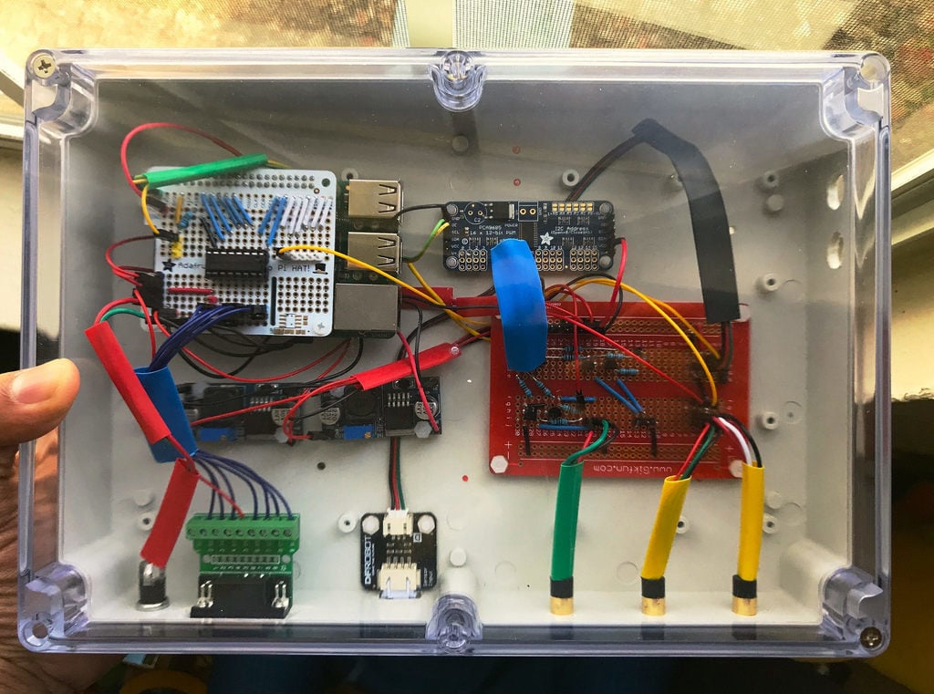

5.3.3 ESP32 Aquarium/Terarrium Controller:
The ESP32 Aquarium/Terarrium Controller project was created by a partnership of people that go by the GitHub name of voltlog [7]. The controller is designed to control water parameters of aquariums and terrariums using an ESP32 microcontroller. THe controller monitors temperature and humidity, and controls heaters, lights, or water pumps through relays. The controller is based on the ESP32 microcontroller and provides a web interface that is hosted by an asynchronous server on the ESP32. This can be beneficial as it provides details on how to use and integrate the microcontroller with parameters of a fish tank, which can be adapted to aid our own solution. In addition, the hardware is affordable and can be scalably as the ESP32 provides a versatile platform that can be expanded on, for example, adding additional sensors to monitor more water parameters. However, the cons of this open source project is that the expansion is limited because the controller primarily focuses on temperature and humidity, making it less suitable for pH, oxygen, and other variables. Although the ESP32 provides a web interface, this open source project does not support any cloud storage or mobile phone app integrations. The license provided on GitHub of this project does permit anyone to copy and distribute, but it does not allow change.
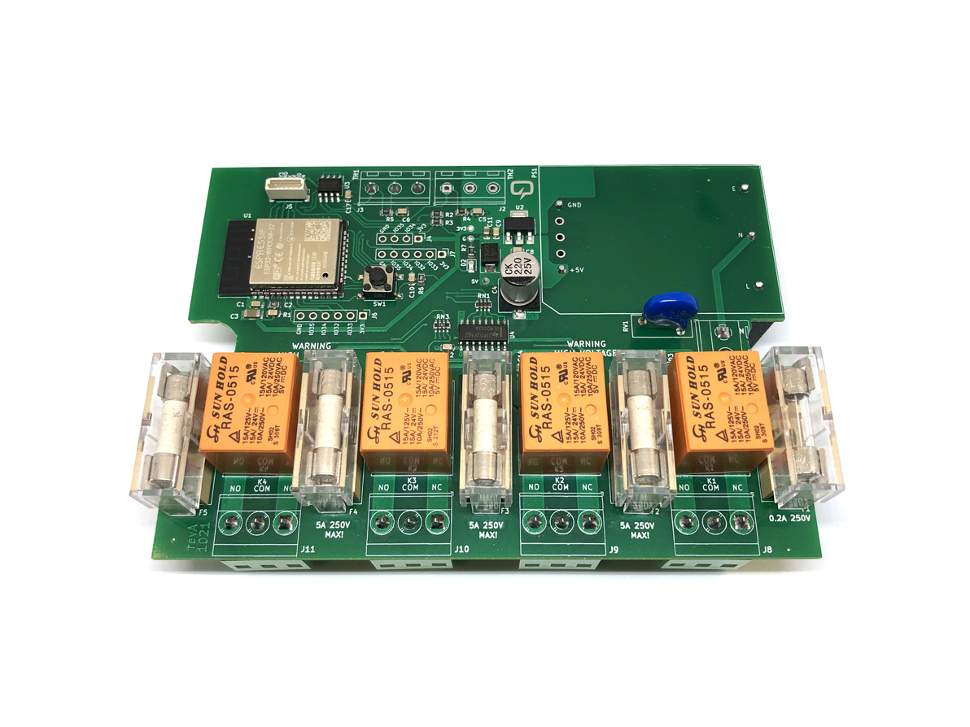

6.0 Sources Cited:
[1] APPA, “Pet industry market size, trends & pet industry statistics from appa,” Pet Industry Market Size, Trends & Pet Industry Statistics from APPA, https://americanpetproducts.org/industry-trends-and-stats (accessed Nov. 03, 2024).
[2]“Aquarium monitor system - Fish Tank water sensor - seneye,” www.seneye.com. https://www.seneye.com/ (accessed Nov. 03, 2024).
[3]“Fishbit - Smart Tools For Beautiful Aquariums,” getfishbit.com. https://getfishbit.com/ (accessed Nov. 03, 2024).
[4]N. Grundmeier, “Apex A3 Series,” Neptune Systems, May 21, 2024. https://www.neptunesystems.com/apex-a3-series/ (accessed Nov. 03, 2024).
[5]Y. Kurkure, “Smart-Aquarium-Project,” GitHub, Jun. 07, 2023. https://github.com/yashkurkure/Smart-Aquarium-Project (accessed Nov. 03, 2024).
[6]“reef-pi Guide 1: Setup and Demonstration,” Adafruit Learning System. https://learn.adafruit.com/reef-pi-installation-and-configuration/introduction (accessed Nov. 03, 2024).
[7]voltlog, “GitHub - voltlog/esp32-aquarium-controller: ESP32 based aquarium/terrarium controller,” GitHub, 2021. https://github.com/voltlog/esp32-aquarium-controller (accessed Nov. 03, 2024).
‌

‌

‌

‌

‌

‌

